Q & A dan corresponding Artikel Journal of Edeucation Technology (JET)

Judul Artikel “"TECHNOLOGY ACCEPTANCE MODEL : THE USE of E-STUDY APLICATIONS IN E-LEARNING".”
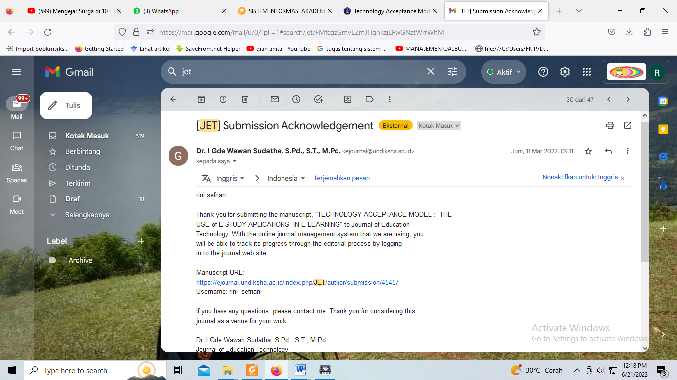
Gambar 1. Submission
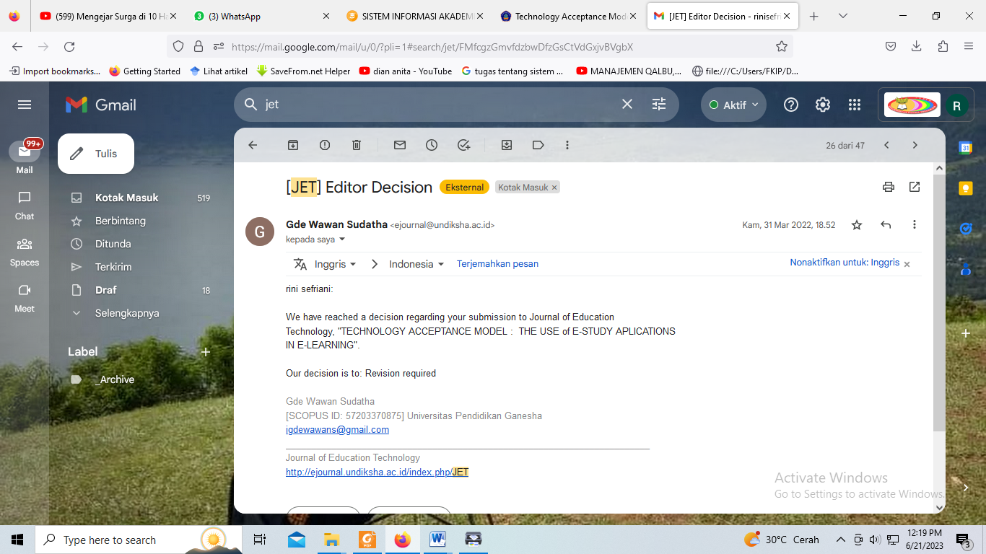
Gambar 2. Revisi

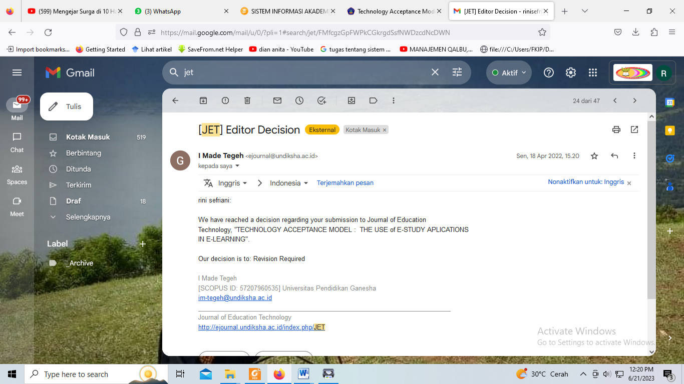
Gambar 3. Revisi
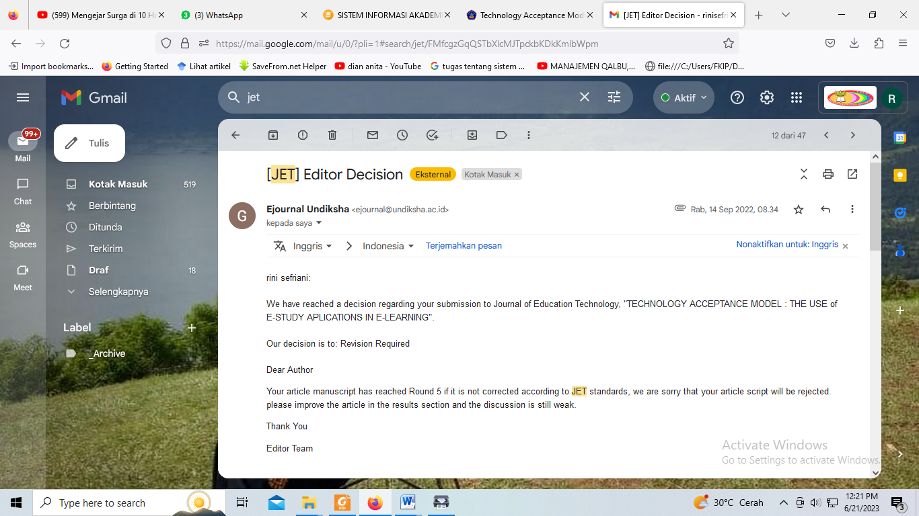
Gambar 4. Revisi

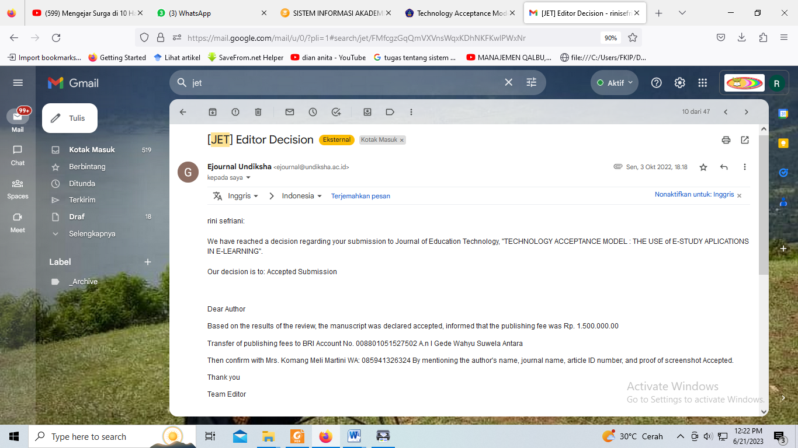
Gambar 5. Accepted

