LAPORAN

NEW LITERACY ORIENTED ICT GUIDANCE MODULE ERA OF INDUSTRIAL REVOLUTION 4.0 IN IMPROVING HUMANITY LITERACY OF STUDENTS

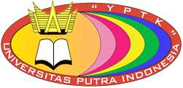

Disusun oleh :

RASMITA, S.PdI., M.Pd
NIDN. 1011068504

UNIVERSITAS PUTRA INDONESIA “YPTK” PADANG
2019

DAFTAR ISI

HALAMAN JUDUL

DAFTAR ISI

DAFTAR GAMBAR

BAB I INTRODUCTION

BAB II LITERATURE REVIEW

New Literation

Humanity Literation

ICT Guidance Module

BAB III METHODOLOGY

Research design

Instruments

Data Analysis

Hypothesis

BAB IV RESULTS AND DISCUSSION

Findings of problems in ICT Guidance

An overview of the ICT Guidance Module

BAB V CONCLUSION

REFERENCES

DAFTAR GAMBAR

Figure 1. Cover of the New Literacy Oriented ICT Guidance module for the Industrial Revolution 4.0.
Figure 2. Map of ICT Guidance Material
Figure 3. Introduction Section and Description of Module Teaching ICT Guidance
Figure 4: Display of Learning Objectives, Learning Outcomes and Instructions.
Figure 5: Task, Summary and Evaluation Views.
Figure 6: Differences in the Average Humanity Literacy Capability.

BAB I

INTRODUCTION

The emergence of the Internet of Thing (IoT) era and disruption phenomena that have caused changes in the world of human life to become information based on the internet. Changes in life in the era of industrial revolution 4.0 caused a shift in the need for competencies that must be owned by HR. As a result the world of education must make adjustments and relevance of education through innovative learning with developments that adjust the needs and development of science and technology by giving attention to literacy and competence in the era of globalization. According to Sudlow (2018) [1] in a review of the latest Proof of Robot book: Higher Education in Joseph E. Aoun in 2017 stated that critical thinking is related to what is the solution for education in preparing the future of students facing the challenges of the 21st century due to shifting demands of the world work in the technological era. As the main capability if we want to produce quality human resources that can be demonstrated in community life, the new literacy is 1) data literacy (the ability to read, analyze, use information (big data) in the digital world, 2) technology literacy (the ability to understand the system machine work), and 3) humanity literacy (humanity, design and communication). The important subjects to be mastered by students are related to the new literacy of industrial revolution 4.0 is Information and Communication Technology which is abbreviated as ICT.
The problem currently faced in ICT learning is the change in the concept of ICT learning into the form of ICT guidance and services in schools as a result of KTSP curriculum changes into the 2013 curriculum. This change was carried out in accordance with Permendikbud with number 68 issued in 2014 CHAPTER I Article 1 which states that ICT teachers turn to become school supervisors, further in Permendikbud chapter iv article 6 states that the duties and responsibilities of ICT teachers are to carry out mentoring and ICT services for students, educators and education staff in schools. This major change eventually caused the ICT learning process to be adapted to coaching needs, and other ICT teachers who were members of the Padang ICT Subject Teachers' Council faced difficulties in adjusting this change. These problems are related to the limited time allocation of ICT guidance causing difficulties for students and teachers in the process of delivering material, learning is often severed when the guidance schedule is only given one lesson. This problem raises the problem of the expected lack of ability for students. The effort that can be made to overcome the problem of change is the development of modules for ICT guidance.
Modules are teaching materials that are developed and presented systematically which have elements of independent learning, and have material to shape students' understanding of the standards of competency expected to be mastered. A good module has characteristics such as being able to help students to learn independently, have complete material, help students have certain skills, be adaptive to technological developments, and form good chaacter or attitude.
Changes in ICT subjects to guide ICT at the junior secondary level demand a change in teaching materials that synergize with the needs of 21st century learning and are integrated with the new literacy capabilities of the industrial revolution era 4.0. The development of ICT guidance teaching modules has produced a module that is designed to teach students independently about ICT material but has more value in strengthening the new literacy capabilities of the industrial revolution era 4.0 namely big data literacy, technology literacy and humanity literacy. Modules are developed using the Four D‘s development model which states that results through the define phase have found the fact that module development is needed because problems are encountered related to the optimization of ICT learning outcomes and the lack of new literacy skills. Furthermore, in the develope phase displayed the results of module development in Microsoft Excel material, the results of the development were tested through experimental True Experimental Design, the purpose of experimental actions to determine differences in humanity literacy skills between the experimental groups. The results of the development have increased the literacy capabilities of the humanity of students with increasing patterns of critical thinking, creativity, communication and cooperation in carrying out the tasks of giving ICT. The purpose of this study was to analyze the increase in humanity literacy abilities of SMP Negeri 23 Padang students by using ICT guidance modules with literacy orientation, new to the era of industrial revolution 4.0.

BAB II

LITERATURE REVIEW

New Literation
Clifton (2016) [2] says it is very possible that universities will experience defeat in the quality of graduates because what is taught does not match the needs of the world. Clifton argues that vocational education faces the challenges of difficulties in the industrial era 4.0. When universities focus on theoretical mastery that does not experience renewal, because it is generally known that automation has replaced a lot of manual work, information technology has replaced clerical work and so on. So the question is what should be done in vocational higher education in the face of challenges in order to succeed in preparing graduates to enter the field of work that is in line with the globalization era's job market. Sudlow (2018) [1] in a review of Robot-Proof's latest book: Higher Education in Joseph E. Aoun stated that critical thinking is related to what is the solution for universities in preparing the future of students to enter the workforce, due to the shifting demands of the world work in the technological era. Aoun argues that New Literacy which covers technology mastery literacy requires the ability of basic technology principles, big data literacy that requires the demands of understanding, interpreting and utilizing big data, and human literacy (humanity) needed by the demands of the social environment, leadership, teamwork, maturity and emotional and social dexterity.

Humanity Literation
Sudlow (2018) [1] in a theory review proposed by Aoun related to the new literacy of the industrial revolution era 4.0 states that things related to humanity literacy that to succeed in the challenges of the globalization era a future workforce must show a higher order of thought. Critical thinking in the concept of education The 21st century is described as "the ability to design and manage projects, solve problems, and make effective decisions using a variety of tools and resources" (Fullan, 2013)[3]. Drake (2014)[4] has the view that critical thinking is the ability to highlight challenges, design learning experiences to overcome local problems and real-world problems that may not have clear answers. Critical Thinking according to Bialik, et al (2015) [5] forms of critical thinking "intellectually as a disciplinary process in active, skilled conceptualization, applying, analyzing, synthesizing, and / or evaluating information collected from, or produced by, observations, experiences, reflection, reason, or communication, as a guide to beliefs and actions. According to Greenstein, L. (2012) [6] critical thinking teaching can be done in various forms, from curricula that train students to identify and practice high-level thinking skills. Gardner (2007) [7] cites "thoughts that create" as one of the thoughts that will need in the future, the educational process requires displaying "exploration, challenging problems, and tolerance. According to Fullan (2013) [2]" creativity includes concepts "Economic and social entrepreneurship and leadership to act." Upitis (2014) [8] argues that creativity in schools gives students experience with situations to find many solutions to problems, where tensions of ambiguity are valued as fertile ground, and imagination is highly valued. currently it is known that only a few professions are based on communication skills (such as therapists, public speakers, customer service), but basically all professions require various forms of communication activities such as negotiations, giving instructions, giving advice, building relationships, resolving conflicts, and so on (Hobbs, 2015)[9]. Hobbs (2015) [9] "Collaboration also requires participants students to develop collective intelligence and build meaning, become content creators and consumers. New skills and knowledge are needed to enable team members to collaborate digitally and contribute to the collective knowledge base, whether working remotely or in shared physical space. "

ICT Guidance Module
Modules are a unit of teaching programs arranged in certain forms for learning purposes. Modules are printed teaching materials designed to be studied independently by learning participants (DG PMPTK, 2008). Russell (2013) [10] says that the module is a teaching package that contains a concept of lesson units. According to Suharjono (2005)[11] modules are materials that are compiled and presented in writing in such a way that the reader is expected to be able to absorb the material itself, with the aim of being an independent learning material for students. Winkel (2009) [12] also stated that the module is the smallest teaching and learning program, which is learned by the students themselves individually or taught by students to themselves (self-instructional).[13][14][15]

BAB III

METHODOLOGY

Research design
This study used the experimental design True Experimental Design, the purpose of experimental action to determine the differences in humanity literacy skills between the experimental groups, namely students who were taught by using ICT guidance modules oriented to literacy skills new era of industrial revolution 4.0.a.SampleSamples from this study were 36 students of class VIII divided into two groups for treatment and control, each of 18 students in each sample group.

Instruments
The instrument used in measuring the level of ability of students in applying humanity literacy is measured by using a questionnaire for student perceptions and observation sheets to observe the behavior of students used by the teacher in determining the ability of students.

Data Analysis
The description of the data uses percentage techniques (%) to explain the categories of humanity literacy abilities of each group of students. Hypothesis testing uses the t test with the Independent formula t test as a comparative test used for paired samples or consists of two different sample groups (treatment and control), the analysis was carried out using the SPSS program.

Hypothesis
The hypothesis proposed in this study are:
    - Hypothesis 1: There are differences in humanity literacy skills on the critical indicator between the control and experimental groups.
    - Hypothesis 2: There is a difference in the ability of humanity literacy on creativity indicators between the control and experimental groups.
    - Hypothesis 3: There is a difference in the literacy ability of humanity on communication indicators between the control and experimental groups.
    - Hypothesis 4: There is a difference in humanity's literacy ability on collaboration indicators between the control and experimental groups.

BAB IV

RESULTS AND DISCUSSION

Findings of problems in ICT Guidance
The research was conducted to analyze the development needs of ICT guidance teaching modules through analysis of emerging problems related to the optimization of the objectives of the intended guidance activities. Based on the results of interviews, observations and documentation, problems can be raised that:

The transition of the ICT subject teacher function becomes an ICT guide.
The problem that arises is that ICT teachers do not have a standard curriculum set by the Ministry of Education and Culture for ICT guidance. This development is a solution to the problems that have been experienced by natural writers as ICT teachers at Padang State Junior High School 23 and a solution for ICT teachers of ICT MGMP members in Padang City.

The emergence of the obligation to develop ICT teaching materials independently.
ICT teachers need learning resources that can be used as teaching materials that are uniform with conformity to the characteristics of curriculum 13 with the characteristics of scientific learning, so the teacher needs a teaching module that can be used by teachers and students containing descriptions of subject descriptions, learning objectives, teaching material, conclusions and evaluation that can help students understand and carry out learning independently. Teaching modules are seen as practical media in facilitating the learning process to foster student learning independence in the guidance of ICTs.

The need to adapt teaching materials to the development of 21stcentury learning.
ICT teachers in developing their learning by innovating on the literacy of the 4.0 industrial revolution by linking learning with critical thinking skills, communication, collaboration and creativity. The teaching materials that are available and used today require renewal that adapts to the learning needs of the globalization era that makes students more active in learning so that learning can be carried out at any time by using modules that are more comfortable to be used to hone students' knowledge based on new literacy in the revolutionary era industry 4.0 that honed the ability of students to be able to have big data literacy, technology literacy and humanity literacy.

Issue of time allocation.
No achievement of expected abilities for students due to time allocation issues. Another problem is the translation of appropriate material has been developed in accordance with the material needs in the basic syllabus in KTSP, because in curriculum 13 there is no standard syllabus for ICT guidance provided by the Ministry of Education and Culture, the teacher needs to develop syllabi in the curriculum itself. This problem causes the teacher difficulty in formulating learning outcomes that are in accordance with the learning needs of students and has no basis in conducting the assessment.

An overview of the ICT Guidance Module
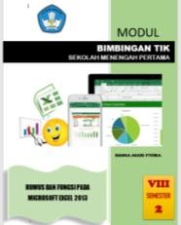
The developed ICT guidance teaching module adapts to the ICT learning objectives which then becomes the guidance of ICT, then adjusts the learning needs of students in responding to global competition in the industrial revolution era 4.0 so there must be as early as possible preparation for students to have new literacy skills namely big data literacy , technology literacy, and humanity literacy. The design of this module was developed through the stages of expert validation and revision aimed at perfecting the module. The following is the display of ICT guidance teaching modules:

Figure 1. Cover of the New Literacy Oriented ICT Guidance module for the Industrial Revolution 4.0.

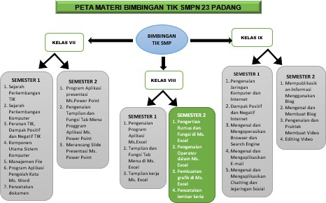

Figure 2. Map of ICT Guidance Material
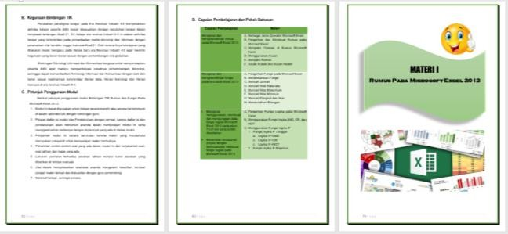
Figure 3. Introduction Section and Description of Module Teaching ICT Guidance.
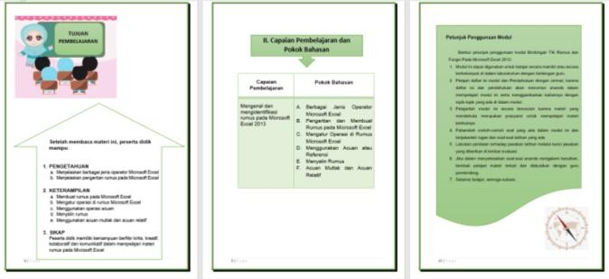
Figure 4: Display of Learning Objectives, Learning Outcomes and Instructions.
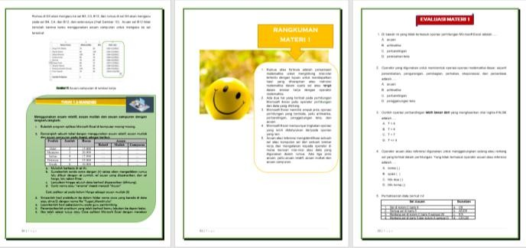
Figure 5: Task, Summary and Evaluation Views.

Hypothesis Testing Results
The results of hypothesis testing to determine the comparison of the literacy capabilities of the control group and the humanity group can be seen in the following table:

Table 1. Independent Sample Test Results t Test of Control and Experiment Groups.

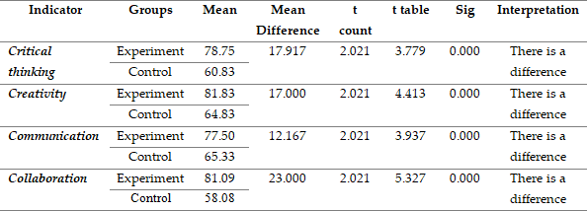

The results of the Independent Sample Test showed that there were differences in the results of humanity literacy skills between groups of students who were taught with ICT guidance modules in the experimental group with students who were taught ICT guidance with conventional modules in the control group. Which group has a higher average score can be seen in the following histogram:
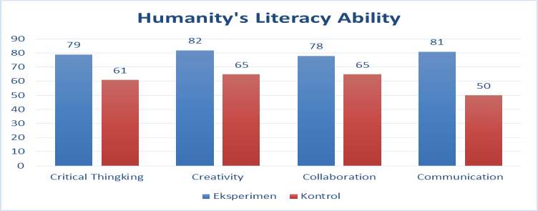
Figure 6: Differences in the Average Humanity Literacy Capability.

The description of the differences in the humanity literacy abilities stated above shows that the experimental group has the ability in all indicators with higher scores than students in the control group. Thus it is stated that the ICT guidance teaching module can improve the literacy skills of the students, and there are differences in the humanity literacy abilities of the two sample groups.

BAB V

CONCLUSION

Based on the results of the research that has been stated, it can be stated that it is necessary to develop ICT guidance teaching modules that have new literacy-oriented skills in the industrial revolution era 4.0 because there are problems in learning outcomes optimization, teacher difficulties in teaching students when ICT guidance and the duties and obligations of ICT teachers to develop ICT learning on its own. The development carried out has produced a valid ICT guidance teaching module based on expert opinion and through a revision process that aims to perfect the products that have been developed. The results of hypothesis testing based on experiments that have been conducted to test whether there are differences in the humanity literacy abilities of students who are taught with modules developed with students in the control group, it is stated that there are significant differences in the humanity abilities of students and the humanity literacy abilities of students taught with ICT guidance modules with indicators of critical thinking, creativity, collaboration and communication are higher than students who learn with conventional modules.
The results of this study recommend that to improve the ability of students to understand to be able to apply the practice of humanity literacy skills, students must be trained by familiarizing learners to use 21st century learning concepts that are loaded with learning independence and access to technology that supports the improvement of students' reasoning for support for internet facilities as a learning resource. Increasing the ability of students to explore their capabilities based on technology must be a reference for teachers to improve the achievement of learning outcomes. By using this ICT guidance module, it is expected that the problems raised earlier in ICT learning can be overcome. The dissemination of modules in the larger classes, especially for MGPM TIK teacher groups in Padang City in particular and throughout Indonesia, can generally be done so that the objectives of ICT-oriented 21st century learning skills can be achieved nationally.

REFERENCES

Sudlow, Brian. 2018. Review of Joseph E. Aoun (2017). Robot Proof: Higher Education in the Age of Artificial Intelligence Cambridge, Massachusetts: The MIT Press. 187 Pp. ISBN 9780262037280. Postdigital Science and Education https://doi.org/10.1007/s4243.
Clifton, Jim. (2016). Universities: Disruption is Coming. http://news.gallup.com/opinion/chairman/191633/universitiesdisruption-coming.aspx.Downloaded 20 March 2019.
Fullan, M. (2013). Great to excellent: Launching the next stage of Ontario‘s education agenda. Toronto: Ontario Ministry of Education. Retrieved from: www.edu.gov.on.ca/eng/document/reports/FullanRepor t_EN_07.pdf.
Drake, S.M. (2014). Designing across the curriculum for ‗sustainable wellbeing‘: A 21st century approach. InF. Deer, T. Falkenberg, B. McMillan, & L. Sims (Eds.), Sustainable well-being: Concepts, issues, and educational practice (pp. 57–76). Winnipeg.
Bialik, M., Bogan, M., Fadel, C., & Horvathova, M. (2015). Character education for the 21st century: What should students learn? Boston, MA: Center for Curriculum Redesign. Retrieved from: www.curriculumredesign.org Downloaded 25 March 2019.
Greenstein, L. (2012). Assessing 21st century skills: A guide to evaluating mastery and authentic learning. Corwin Press.
Gardner, Howard. (2007). Five Minds for the Future. Boston, MA: Harvard Business School.
Upitis, R. (2014). Creativity: The state of the domain. In People for Education, Measuring What Matters. Toronto. Retrieved from: http://peopleforeducation.ca/measuring-what-matters/domain/creativity andinnovation/. Downloaded 20 March 2019.
Hobbs, R., & Frost, R. (2015). Measuring the Acquisition of Media-Literacy Skills. Reading Research Quarterly, 38(3), 330–355.
Russell, J. E. A dan Bernardin, H. J. (2013), Human Resource Management, Sixth Edition. New York: McGrawHill.
Suharjono. (2005). Penelitian Tindakan Kelas. Jakarta: Bumi Aksara.
K. Rukun, B. H. Hayadi, I. Mouludi, A. Lubis, Safril, and Jufri, ‗Diagnosis of toddler digestion disorder using forward chaining method,‘ in 2017 5th International Conference on Cyber and IT Service Management, CITSM 2017, 2017.
B. H. Hayadi et al., ‗Expert system of quail disease diagnosis using forward chaining method,‘ Indones. J. Electr. Eng. Comput. Sci., vol. 5, no. 1, pp. 207–214, 2017.
C. Systems et al., ―Implementation Competency Based Learning Model Of Learning Computer Network Courses At Vocational Education,‖ vol. 11, no. 5, pp. 501–505, 2019.
R. Pi, ―The Implementation of Calendar Academic Monitoring System in University Using,‖ vol. 11, pp. 497–500, 2019.

